Jenette Smith  
Homework #2 VBA  
SMU Bootcamp  
Oct. 11, 2020

**Purpose:** This homework helped with having a greater understanding of VBA using Excel with real-life stock industry data.

**Challenges:** VBA is more difficult to understand and it takes more time to code in VBA than in Python.

**Screen Shots:**

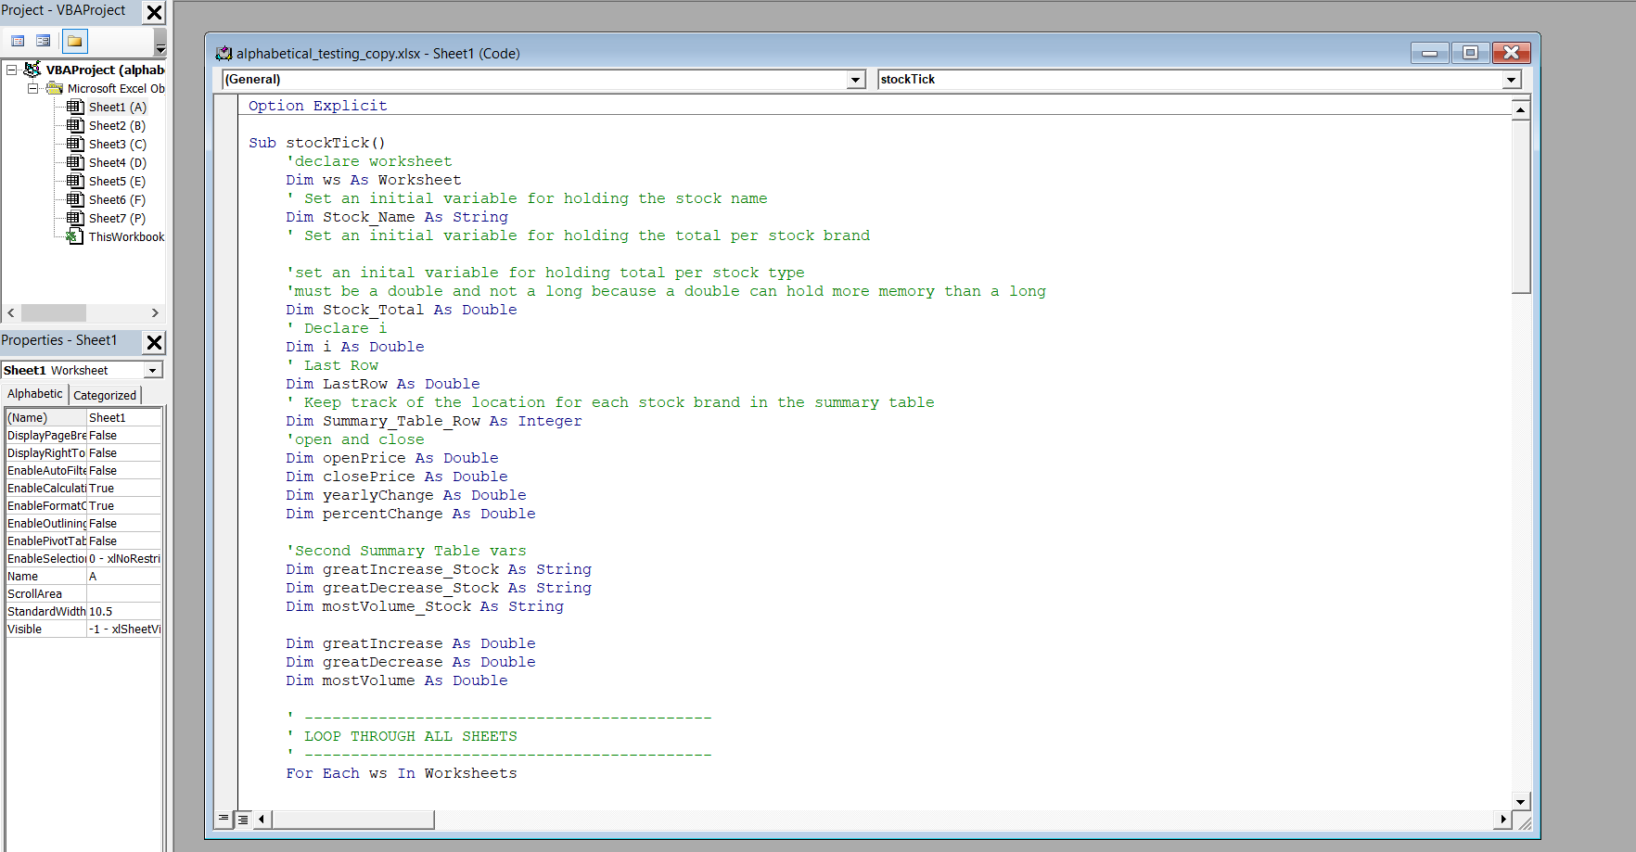

**Sheet A**

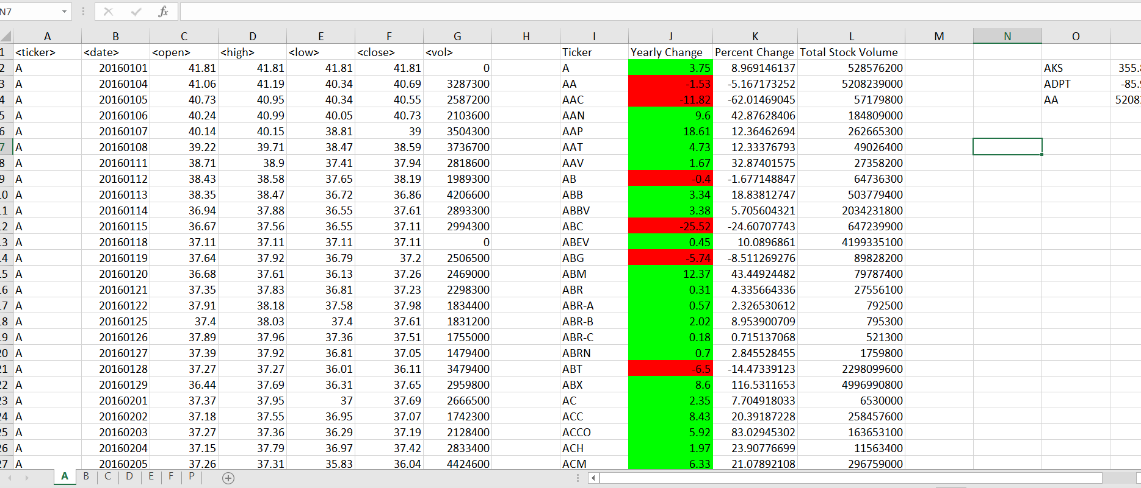

**Sheet B**

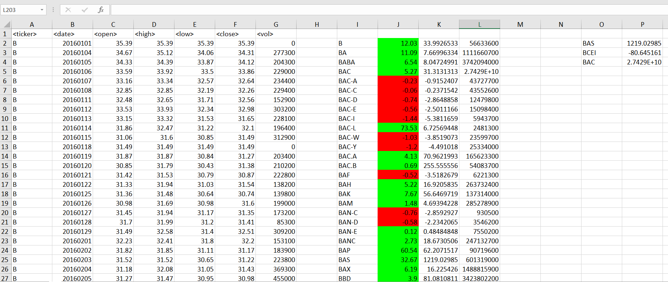

**Sheet C**

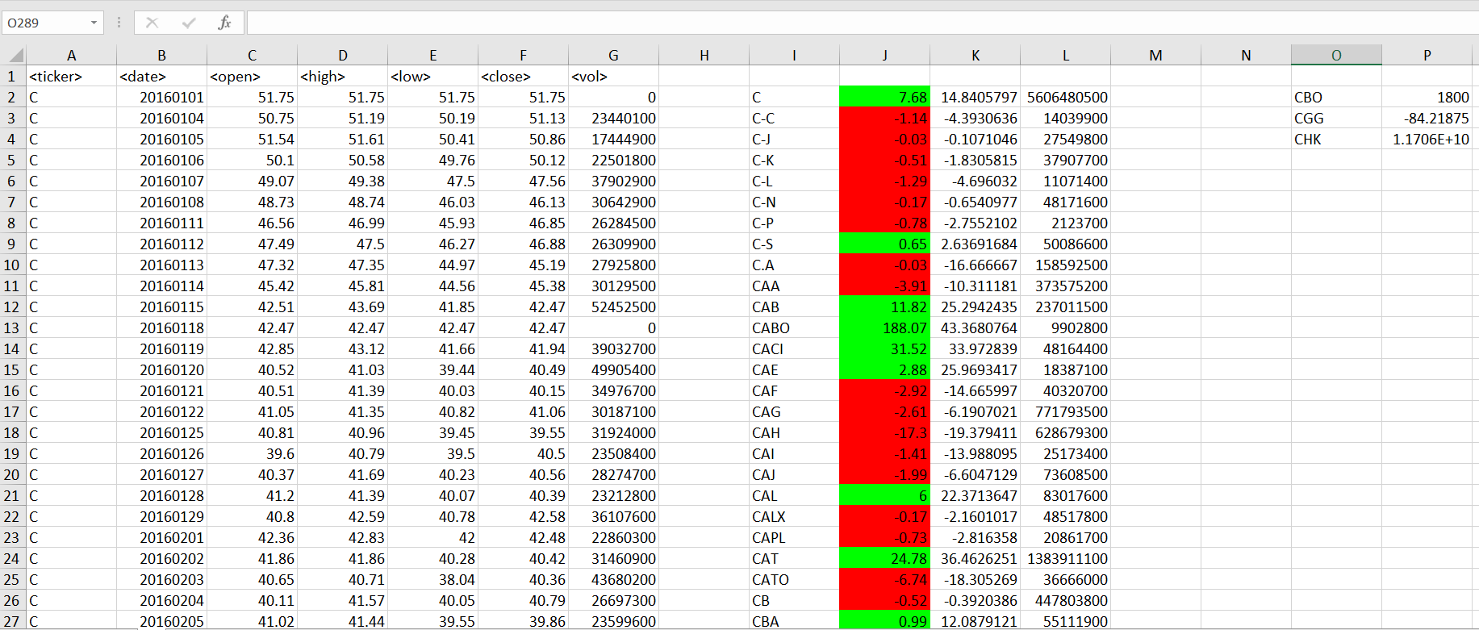

**Sheet D**

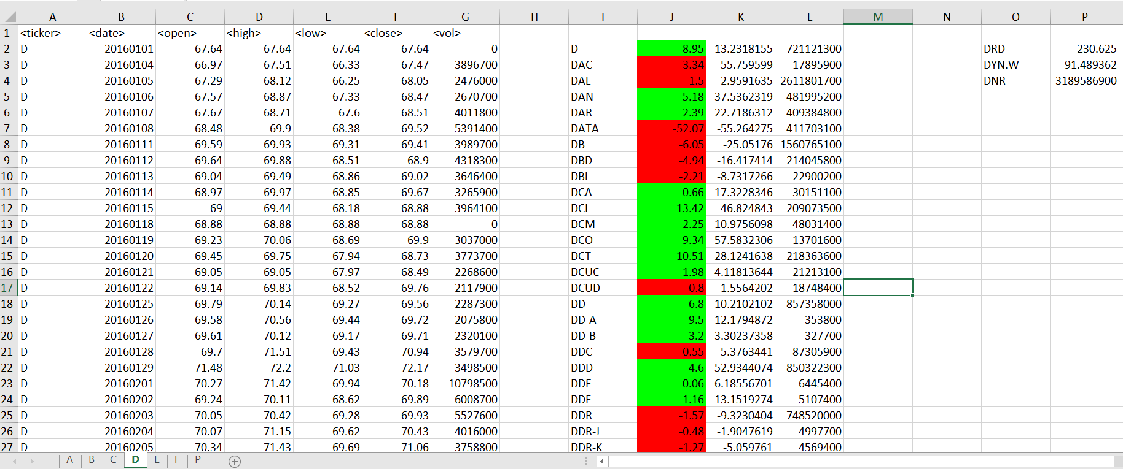

**Sheet E**

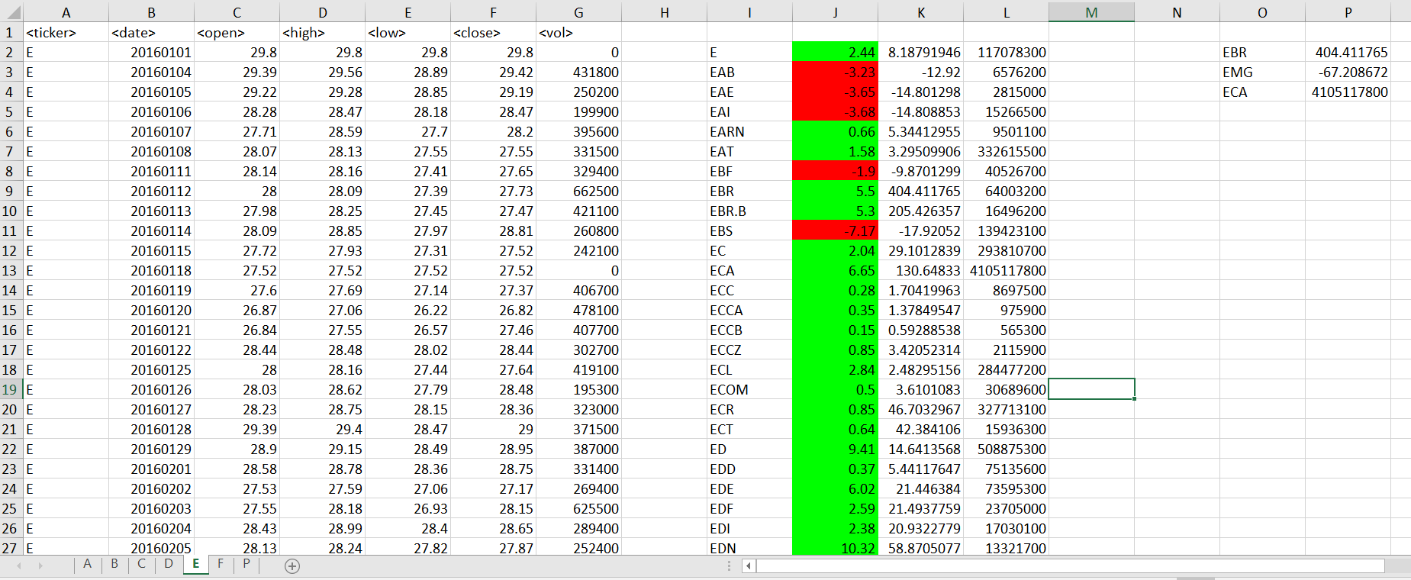

**Sheet F**

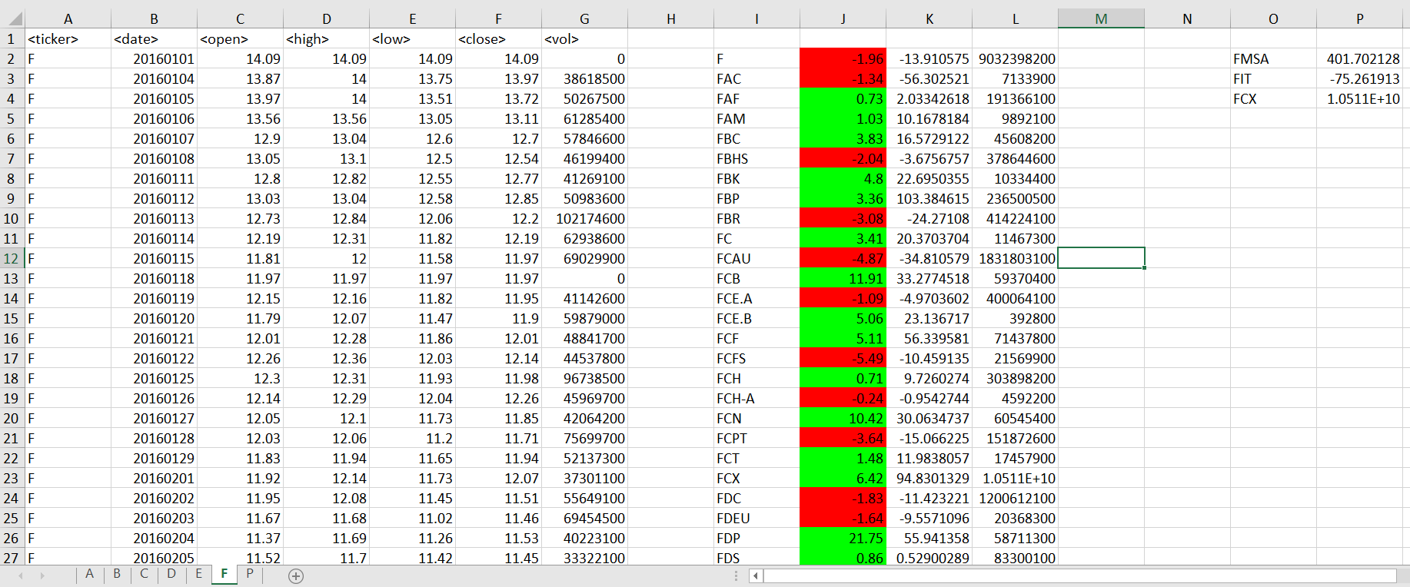

**Sheet P**

